SMART Trouble Shooting Tips
Listed below are just a few fixes that we have found work to get a positive connection between the board and laptop/docking station. Please remember prior to trying any of these solutions, make sure ALL components are plugged in correctly and into the correct port on the wall, and that you have installed the SMART Notebook software from the software center and restarted your machine.

Situation 1: NEW Boards
- Unplug the USB from the present port and plug into a different port on the docking station or laptop.
- Go into the SMART System Menu/SMART Settings and run the Connection Wizard.
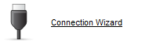
  - If you need to choose a product, choose M600.

- If the Connection Wizard does not work then proceed to unplugging the USB and Power adapter from up under the SMARTBoard tray.
  - You will need to unplug both the USB connection and the power adapter. Then, let them sit for about 2 minutes.
  - When you prepare to re-plug them in, plug the power adapter in first then, the USB connection.

Situation 2: Existing Boards paired with Epson Projector
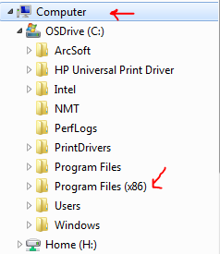
- If none of the above work you may need to run the SMART Firmware updater. Follow the directions below.
  - Go to Computer
  - Cdrive
  - Program Files (x86)
  - SMART Technologies
  - Education Software
  - SMART Firmware Updater:
  - Click Run

